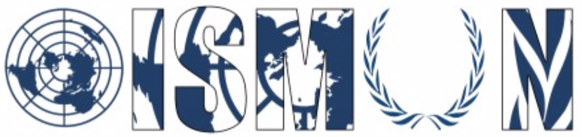
Oasis International School Model United Nations
Economic and Social Council Sub-Commision 2: Status of Women
Chair: Menna Kotb
Co-chair: Abd El Rahman Waleed

Guiding Package

Topic 2 : Ensuring the right to women’s healthcare

10th Annual OISMUN Conference

3rd -6th of November 2017

Table of Contents 2
I. Abstract 3
II. Introduction 4
III. Key terms 5
IV. Major Parties involved 6
V. Major Organisation Involved 6
VI. Guiding questions 7
VII. UN Involvement 8
VIII. Possible Solutions 9
IX. Useful Links 9
X. Bibliography 10

I. Abstract:
The right to access health care is a basic fundamental right for every human being, indifferent of his or her gender, country and social status. Humans around the world; especially women should have access to a proper and adequate health care. Women's health care is relevant as it has an impact on the health and the development of the next generation seeing as they are those who bear children. According to the Constitution of the World Health Organization, WHO "Health is a state of complete physical, mental and social well-being and not merely the absence of disease or infirmity.” The leading cause of death among women of reproductive age is HIV/AIDS. Road traffic injuries, burns, homicides and suicide are also causes of death for adolescent girls. For women over 60 years of age, cardiovascular disease, chronic obstructive pulmonary and stroke are major killers. Woman's death toll has risen because of inequalities within countries because of gender, differences between high-and low-income countries and health related laws who have failed women and deprived them from obtaining their rights. WHO have also stated that around 222 million women are not getting the services they need and that 300,000 women have died while giving birth.

II. Introduction:
According to The World Bank, Women make up approximately 50% of the world population. They represent a significant unit in today’s society as they play a number of roles; being a mother, a sister and a cousin. Not only do they possess a vital place; they also contribute enormously to the development of their countries politically, socially and economically. For years, Women’s health care differs from men’s those of Women, around the world still face many health difficulties even after the 1995 Beijing Declaration.

III. Key terms:
- Continuum of care: An approach to maternal, newborn, and child health that includes integrated service delivery for women and children from before pregnancy to delivery, the immediate postnatal period, and childhood.
- Contraception: The intentional prevention of pregnancy or conception through hormones, technologies, sexual practices, or surgical procedures
- Female genital cutting: All procedures involving partial or total removal of the external female genitalia, or other deliberate injury to the female genital organs, whether for cultural, religious or other non-therapeutic reasons.
- Gender: The cultural, social, and economic responsibilities, attributes, and opportunities associated with being male or female.
- Gender-based violence (GBV): Any act threatened or actual act of aggression that targets a person based on their gender. Gender-based violence can occur on an individual, community, or societal level.
- Maternal death: The death of a woman while pregnant or within 42 days of the termination of pregnancy, due to complications during pregnancy or childbirth.
- Maternal health: The health of women during pregnancy, childbirth, and the postpartum period.
- Maternal morbidity: Any injury, condition or symptom that results from, or is worsened by pregnancy.

IV. Major Parties involved
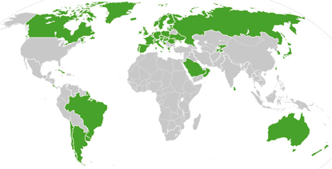

The above map shows in green, countries that administer some sort of universal health care plan. Most are through compulsory but government-subsidized public insurance plans, such as the UK's National Health Service. Some countries that have socialized and ostensibly universal health care systems but do not actually apply them universally, for example in poverty- and corruption-rife states in Africa or Latin America, are not counted.

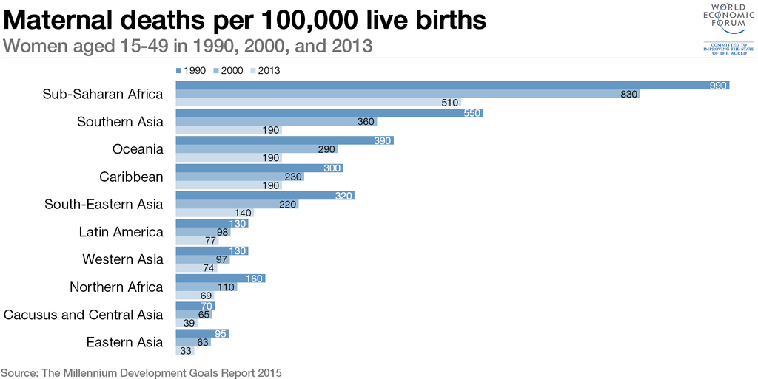

http://www.who.int/life-course/news/commentaries/2015-intl-womens-day/en/

V. Major Organizations Involved:
- World Health Organization:
The world health organization (WHO) is a specialized agency of the United Nations that is concerned with international public health. It was established on 7 April 1948, headquartered in Geneva. Its goal is to build a better and healthier future for people around the world. The WHO works with governments and other organizations to ensure adequate health for all women around the world.
The WHO helps mothers and children survive and thrive so they can look forward to a healthy old age. The WHO site states “The health of women and girls is of particular concern because, in many societies, they are disadvantaged by discrimination rooted in sociocultural factors. For example, women and girls face increased vulnerability to HIV/AIDS.”
b) International Women’s health coalition:
Founded in 1984, The International Women’s Health Coalition (IWHC), aims to spread sexual and reproductive rights and health among women and girls worldwide, especially in Africa, Asia, and Latin America. The IWHC fights for the implementation of policies that are beneficial for women and girls in developing areas. It also provides educational aid to local activists and community leaders.

c) The Office on Women's Health
The Office on Women's Health (OWH) was established in 1991 within the U.S. Department of Health and Human Services (HHS). OWH coordinates women's health efforts across HHS and addresses critical women's health issues by informing and advancing policies, educating healthcare professionals and consumers, and supporting model programs.

VI. Guiding questions:
- What kind of health issues do women face today in the world ?
- Are the existing healthcare organizations today in the world enough to support women’s health issues ?
- Are women around the world getting equal healthcare?
- How is your country involved in women’s health care internationally?
- What solutions can be put in place to provide adequate healthcare to women?
- Is the national healthcare present in your country enough to support your female’s population ?

VII. UN Involvement:
The concept of a right to health has been enumerated in multiple international agreements, which includes the Universal Declaration of Human Rights, International Covenant on Economic, Social and Cultural Rights and the Convention on the Rights of Persons with Disabilities.

- In 1979, the general assembly adopted the Convention on the Elimination of All Forms of Discrimination against Women (CEDAW) which gathered almost one hundred nations. According to article 12 , countries should take “all appropriate measures to eliminate discrimination against women in the field of health care in order to ensure, on a basis of equality of men and women, access to health care services, including those related to family planning”

VIII. Possible Solutions:
- Send annual troops to countries in need of health care to help provide adequate healthcare in rural regions.
- Provide financial aid by the WHO to countries suffering from poverty with women health issues
- Create and develop women’s health care organizations seeking to provide sustainable healthcare in developing countries

IX. Useful Links:
- World Health Organisation (WHO), «Women and Health», available on: http://www.who.int/gho/women_and_health/en/, consulted the 30th of September 2017
- FLAVIA, Bustero, «Ten top issues for women's health», (3rd of March 2015), avaible on: http://www.who.int/life-course/news/commentaries/2015-intl-womens-day/en/ , consulted the 30th of September 2017

X. Bibliography
- Encylopedia brtitanica, “International Women’s Health Coalition (IWHC)” available :https://www.britannica.com/topic/International-Womens-Health-Coalition consulted 30 september 2017
- International women’s health coalition. “ What we do”. Available on https://iwhc.org/what-we-do/ consulted 30 september 2017
- Everyday health. “ A Guide to Women's Health Organizations” available on https://www.everydayhealth.com/womens-health/guide-to-womens-health-organizations.aspx consulted 30 september 2017
- World health organization. “ Ten top issues for women's health” available on .http://www.who.int/life-course/news/commentaries/2015-intl-womens-day/en/ consilted on 30 september 2017

