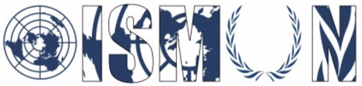Oasis International School Model United Nations

Economic and Social Council Sub Commision 2: Crime Prevention and Criminal Justice
Chair : Jessica Saba
Co-Chair: Ibrahim Hossam

Guiding Package

Topic 1 :Measures to eliminate human trafficking and migrant smuggling

10th Annual OISMUN Conference

November 2017

Table of Contents
Abstract 3
Introduction 4
Definition of Key terms 5
Background Information 5
Major countries and organizations involved 6
UN involvement 9
Possible solutions: 12
Guiding Questions 13
Useful links 13
Biography 15

I. Abstract
Slavery has been abolished since the mid 19th century, yet till now, we can find examples of neo-slavery in the form of human trafficking and migrant smuggling victims. These crimes exploit people and deny them their basic human rights that our modern world grants. Not only is it a violation of said people’s rights, it is also a violation of the laws of any sovereign state. As children, we imagine our future to be in our hands, we crave freedom, we crave autonomy yet some people never get the liberty and freedom they deserve. These actions are unlawful, unethical and lead to the objectification of humans. According to the United Nations Office on Drugs and Crime,The smuggling of people to the United states generates approximately 6.75 billions USD a year, and human trafficking is a very spread epidemic with an estimate of 21 million victims of trafficking in the United States alone. That is why, it is essential to fight and prevent the trafficking in persons and migrant smuggling, to return victims to society where they can lead a productive life. The commission's goal is to fight and prosecute the oppressors and criminals who confiscate a person’s lawful entitlement.

II. Introduction
Every year, thousands of men, women and children are being abducted by traffickers in their own country or abroad. Human trafficking is a serious and grave crime and a severe violation of human rights. Almost every country in the world -such as Iran and the Russian Federation- is affected whether it be as country of origin, transit or the destination of victims. In other words the countries belonging to the 2nd tie, the 2nd tier watchlist and the 3rd tier “send” or “receive” thousands of victims every year. There are many different types of human trafficking, including forced labor, domestic servitude and sexual exploitation as well as child labor and child recruitments of militia organizations. There are three elements to Human Trafficking: the act; is what is done which is the recruitment and harboring of a victim. The means; how it is done which is by the use of force, threat or coercion and finally the purpose; why it is done; generally, human trafficking occurs for for the purpose of exploitation which includes sexual exploitation, forced labor, and domestic servitude.
On the other hand, migrant smuggling based on article 3 of the Protocol against the smuggling of migrants by land, sea and air written by the United Nation in 2000 recalling the General Assembly’s resolution number 54/212 in 1999 is the "procurement, in order to obtain, directly or indirectly, a financial or other material benefit, of the illegal entry of a person into a State Party of which the person is not a national or a permanent resident." This means that the smuggler is obtaining financial or material benefit in order to help a migrant enter a state or a country in which he is not a legal resident, making him an illegal migrant. It is essential to fight these inhumane acts and to restore the victims of trafficking and smuggling their deserved rights. There are of course some advantages to ending human trafficking and migrant smuggling including; the protection of victims of forced labor, sexual exploitation and modern day slavery. As well as the touristic and economic benefits of a country by legal immigration. But to all advantages there are consequences for example the end of human smuggling might be the cause of the loss of many lives that are in danger, that of the people who tried the process of legal immigration but were not successful.

III. Definition of Key terms
- Human trafficking: the recruitment, transportation or harboring of people by means of force, deception or coercion.
- Migrant smuggling: the procurement, in order to obtain, directly or indirectly, a financial or other material benefit, of the illegal entry of a person into a State Party of which the person is not a national or a permanent resident.
- Forced labor: Through violence, fraud or coercion victims of forced labor are made to work for little or no pay
- Domestic servitude: Victims of domestic servitude are hidden in plain sight, they are often forced to work as caretakers, nannies, maids or domestic help.

IV. Background Information
Human trafficking began in the distant past with slavery, which was legal and allowed by governments till the mid 1800s. But in the modern era, it is recognized to have begun as white slavery in the 1900s ; it commonly involved the procurement of sexual and monetary exploitation of women and young girls. Many historians state that there was demand that led to the trading of women back then due to the illegality of slavery and the misogynistic societies of the time. The world community took actions by establishing treaties like the International Agreement of the suppressions of the white slave traffic of 1910 and in 1921 with the international convention for the suppression of the traffic in Women and Children. These conventions declared the international community’s views on the topic of trafficking, slavery is abolished in our current world, yet traffickers are coercing humans out of their right to freedom, choice and liberty. While the trafficking of persons has been mostly present for the entirety of human history, migrant smuggling is more of a modern issue, since it relies on the unlawful passing of state borders, a notion that is present since the dawn of nations yet only enforced in the recent times. By studying migrant smuggling cases, the United Nations Office on Drugs and Crime was capable of identifying major trends, like the smuggling from poor communities like eastern Europe, east and south Asia, sub-Saharan Africa and south America ; towards major economic regions like the middle east, eastern and central Europe and north and central America. These flows are mostly due to the socio-economic state of said communities. These regions have high cases of poverty, famine, low life expectancies and many more inhumane conditions. A smuggled migrant’s goal is to have a better life for them and their family (mostly children). That is why the UN is fighting the smuggling process and also encouraging the improvement of communities to get rid of the urge/need to smuggle migrants, like with the 2000 protocol against the smuggling of migrants by land, sea and air.

V. Major countries and organizations involved
Organizations:
- U.S Department of Homeland Security: Blue Campaign -United States of America
The Blue Campaign is the unified voice for the U.S. Department of Homeland Security’s (DHS) efforts to combat human trafficking. It was established in 2002 and works in collaboration with law enforcement, government, non-governmental and private organizations. The Blue Campaign strives to protect the basic right of freedom and to bring those who exploit human lives to justice. Their first action was to raise awareness on the issue of human trafficking letting citizens get involved if they know information about any victim in need of help. Moreover, eighteen of the U.S Immigration and Customs Enforcement officials otherwise known as ICE officials are hired full time to assist victims of human trafficking and recognize further victims. Furthermore, the department of Homeland security works with multiple international and private sector organizations to aid victims of human trafficking and bring traffickers to justice.
- INTERPOL: International Criminal Police Organization -Global Police Organization
The International Criminal Police Organization is one of the largest police organization with 190 member countries. Their goal is to support national police organizations in the field by sending troops during tactical deployments to help break up the criminal networks behind trafficking in persons. Some of their operations include the ongoing Operation Akoma in 2015 where more than 150 children between the ages of five to sixteen were rescued, and led to more than 25 arrests of traffickers so far.

- EUROPOL: European Union’s law enforcement agency -European Union
Europol is the European Union’s law enforcement agency. Its main goal is to achieve a safer Europe for the benefit of all EU citizens. Headquartered in The Hague, the Netherlands, they assist the 28 EU Member States in their fight against serious international crime and terrorism. They also work with many non-EU partner states and international organisations. EUROPOL’s main criminal priority is fighting terrorism, cybercrime and people smuggling to avoid any severe threat to the safety and livelihood of its people.

- The Not for Sale Campaign - Global Organization
Not for Sale is an international non-profit organization based in San Francisco, California, founded in 2001. It works to protect people and communities around the world from human trafficking and modern-day slavery. The organization partners with leading companies and organizations to create long-term employment opportunities for survivors and at-risk communities. They also provide them with shelter, healthcare and legal services.

Countries:
The United Nations appointed the United States of America to categorize all countries in three tiers according to their efforts to comply with the international minimum standards of the “Trafficking Victims protection Act”. In which tier one represents the countries that fully comply with the standards of the act. Tier 2 represents the countries who do not fully comply with the minimum standards but are making efforts and progress to comply with them. Finally tier 3, represents the countries that do not comply at all with the international minimum standards of the Protection Act and are not making any progress or efforts to comply with them. The following diagram represents the countries belonging to each tier, according to the U.S department of State website.
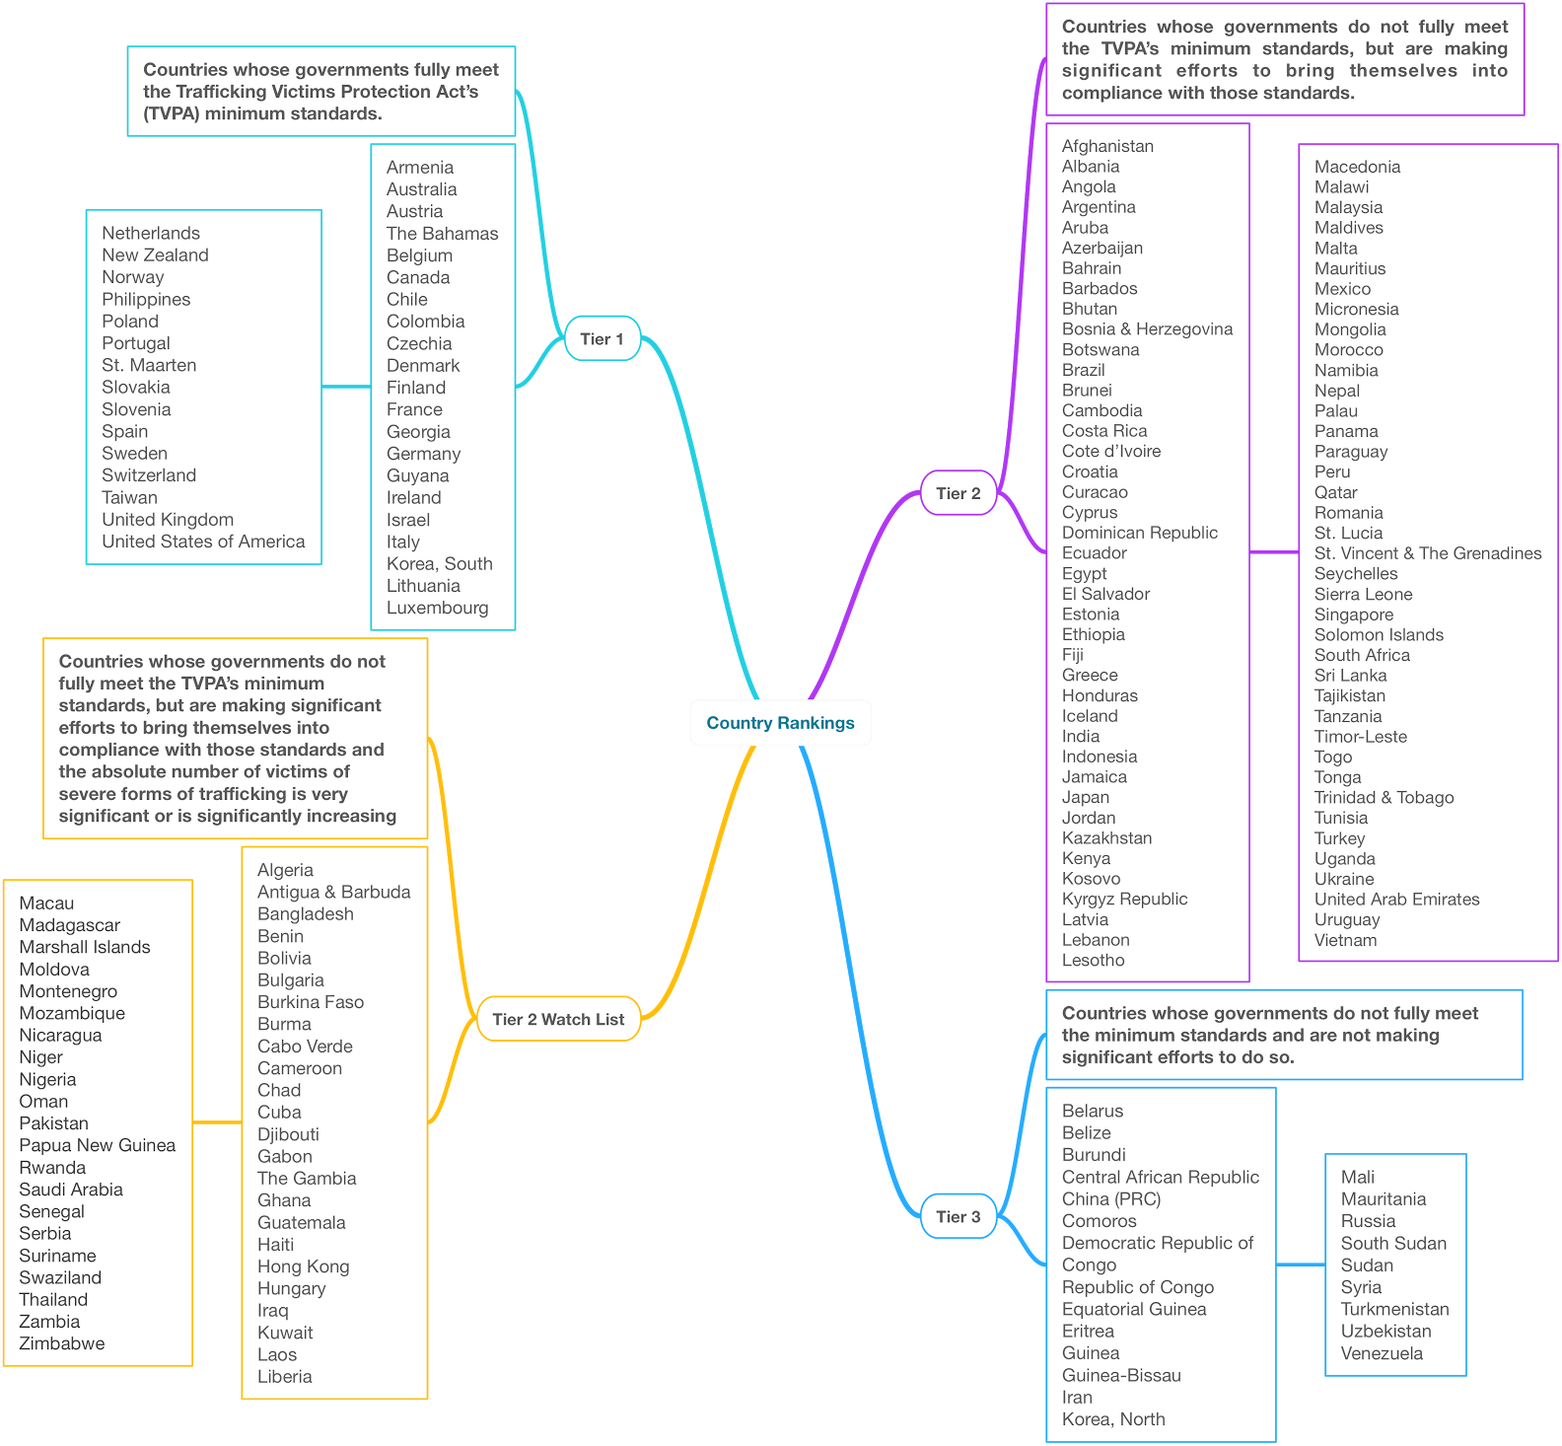

- The People’s Republic of China
The Chinese State contains all types of human trafficking and migrant smuggling. The US has recently declared it to be among the worst human trafficking offender; while confirming that the state is a “source, destination and transit country” for forced labor and sex trafficking. According to the United Nations Office on Drugs and Crime (UNODC), the smuggling between China and the US earns 3 billion USD a year. Two years ago, the international media was able to find evidence of chinese local officials coercing men and women to participate in forced labor. Also, the People’s Republic still has not criminalized the trafficking and exploitation of minors, a clear human rights violation.

2. The Russian Federation
The Russian State has been considered one of the worst offenders of trafficking in persons since 2012. The government has “maintained, and recently expanded, bilateral contracts with the Democratic People’s Republic of Korea … under which the North Korea operated labor camps on Russian soil and subjected thousands of North Korean workers to forced labor”. The Russian authorities have also deported potential trafficking victims without researching for any signs of exploitation. The federation disregards any need for trafficking rehabilitation or even allow private shelters that might provide that same function.

3. The Islamic Republic of Iran
According to a “Trafficking in persons” report written by the U.S Department of State, The Islamic Republic of Iran “is a source, transit, and destination country for women and girls trafficked for the purposes of sexual exploitation and involuntary servitude” Even though, in the same report, Iran has made some efforts to punish traffickers. The report states “a number of government officials, including members of the State Security Forces and Islamic Revolutionary Guard Corps, were arrested for engaging in the commercial sexual exploitation of children”.

4. The Republic of Guinea-Bissau
Guinea-Bissau, a small west-African country, has been plagued by trafficking in persons, especially the trafficking of children. According to the US Department of State, boys are trafficked to Senegal, where they are forced to beg by religious teachers known as the marabouts. In 2010, the UNICEF declared that almost 200 children are smuggled a month from the country. Then in 2014, the US State Department declared a large increase in forced labour in agricultural location and mines. And unfortunately, they also stated that there is also an increase in domestic labor and forced prostitution in trafficked/smuggled children.

5. The Republic of Sudan
Sudan has always been a country facing harsh socioeconomic conditions, and consequently these conditions have increased trafficking in persons and smuggling. There are major rebel organizations who thrive on trafficking in persons and forced labor. A known example is the Lord’s Resistance Army rebel group, they harbor sudanese minors to be used as soldiers or laborers. Sudanese trafficking isn’t only present in Central Africa, but back in 2007, greek law enforcement found a trafficked sudanese girl in the Hellenic Republic. Most reports on trafficking in the country showed that most victims were male minors. Unfortunately, in 2010, the US Department of State released a report demonstrating that there has been a surge of female trafficking. They also claimed that the traffickers are capable of doing so due to the aid of law enforcement officials.

VI. UN involvement
The United Nations took many initiative to help prevent human trafficking and migrant smuggling and protect victims of said crimes. They created organizations to raise awareness. They also joined other organizations to create coordination between international organizations in order to achieve their goal. One of these joint acts is the Global Action against Trafficking in Persons and the Smuggling of Migrants (the Glo.Act) which is a four year joint initiative between the United Nations Office on Drugs and Crime, UNODC and the European Union. It started in 2015 and plans to end in 2019. It is being implemented in partnership with the International Organization for Migration, IOM and the United Nations Children’s Fund, UNICEF. It is expected to be part of a joint response to trafficking in persons and the smuggling of migrants and should be able to deliver in up to 15 strategically selected countries across Africa, Asia, Eastern Europe and Latin America. United Nations General Assembly mandated a policy forum called the ICAT; the Inter-Agency Coordination Group against Trafficking in persons. It is mandate to improve coordination amongst the United Nations agencies and other relevant international organizations to facilitate a holistic and comprehensive approach to preventing and combating trafficking in persons, including protection and support for victims of trafficking.
Furthermore, the United Nations Office on Drugs and Crime created laws and conventions against transnational crimes, such as the model law against smuggling of migrants which was created in response to a request by the General Assembly to the Secretary-General to promote and assist the efforts of Member States to become party to and implement the United Nations Convention against Transnational Organized amd the protocols thereto, which was adopted by the General Assembly resolution number 55/25 of the 15th of November 2000 and is the main international instrument to fight against transnational organized crime.

VII. Possible solutions:
- Improving the awareness of human trafficking and migrant smuggling signs is paramount for finding a solution. Therefore there is also a large need for increasing the presence of first responders. A possible way to improve awareness is to present the issue in school seminars and in televised programming.
- Endorse the strengthening of judicial bodies around the world in the trafficking in persons domain. That allows people to fight traffickers lawfully in court and receive the proper treatment required. The endorsement is necessary to respect a country’s sovereign state.

VIII. Guiding Questions:
- How can socio-economic issues lead to human trafficking and migrant smuggling ?
- Why is migrant smuggling common in Asia and South America ?
- What are the differences between combating a crime against the state and combating a crime against an individual ?
- What are prevailing methods to ease and indoctrinate people into human trafficking groups ?
- How and why are victims of trafficking and smuggling exploited ?
- Where are there spikes of migrant smuggling/human trafficking and is there any correlations ?
- How will eliminating human trafficking and migrant smuggling affect your country ?
- What resources and/or aid can your country provide to help eliminate the issues at hand ?
- Does completely stopping migrant smuggling aid solving the problems that already encouraged said act ?
- Is your country taking action against trafficking in persons ? if yes how ?

IX. Useful links
- United Nations Office on Drugs and Crime “ Human Trafficking Knowledge Portal” Available on https://www.unodc.org/cld/en/v3/htms/index.html Consulted on the 26th of July 2017
- United Nations Office on Drugs and Crime “ UNODC on Human trafficking and Migrant Smuggling” Available on https://www.unodc.org/unodc/en/human-trafficking/index.html?ref=menuside. Consulted on the 26th of July 2017
- United Nations Office on Drugs and Crime “Human Smuggling Knowledge Portal” Available on https://www.unodc.org/cld/en/v3/som/ Consulted on the 27th of August 2017
- The Inter-Agency Coordination Group against Trafficking in persons. Available on http://icat.network/. Consulted on the 27th of August 2017
- United Nations Office on Drugs and Crime “ Global Report on Trafficking in Persons 2014” Available on http://www.unodc.org/documents/data-and-analysis/glotip/GLOTIP_2014_full_report.pdf. Consulted on the 27th of August 2017
- U.S Department of Homeland Security “Tools that Teach: What is Human Trafficking?” Available on https://www.youtube.com/watch?v=35uM5VMrZas. Consulted on the 27th of August 2017
- U.S Department of Homeland Security “The Blue Campaign” Available on https://www.dhs.gov/blue-campaign.Consulted on the 27th of August 2017
- Somaly Mam “How to end Modern Slavery and Human Trafficking” Available on https://www.forbes.com/sites/skollworldforum/2013/11/15/how-to-end-modern-slavery-and-human-trafficking/#44fcad5b5405. Consulted on the 27th of August 2017
- United Nations Office on Drugs and Crime “ United Nations Convention against Transnational crimes and the Protocols thereto” Available on http://www.unodc.org/documents/treaties/UNTOC/Publications/TOC%20Convention/TOCebook-e.pdf. Consulted on the 3rd of August 2017

X. Biography
- United Nations Office on Drugs and Crime “ Human Trafficking Knowledge Portal” Available on https://www.unodc.org/cld/en/v3/htms/index.html Consulted on the 26th of July 2017
- United Nations Office on Drugs and Crime “ UNODC on Human trafficking and Migrant Smuggling” Available on https://www.unodc.org/unodc/en/human-trafficking/index.html?ref=menuside. Consulted on the 26th of July 2017
- United Nations Office on Drugs and Crime “Human Smuggling Knowledge Portal” Available on https://www.unodc.org/cld/en/v3/som/ Consulted on the 27th of August 2017
- The Inter-Agency Coordination Group against Trafficking in persons. Available on http://icat.network/. Consulted on the 27th of August 2017
- United Nations Office on Drugs and Crime “ Global Report on Trafficking in Persons 2014” Available on http://www.unodc.org/documents/data-and-analysis/glotip/GLOTIP_2014_full_report.pdf. Consulted on the 27th of August 2017
- U.S Department of Homeland Security “Tools that Teach: What is Human Trafficking?” Available on https://www.youtube.com/watch?v=35uM5VMrZas. Consulted on the 27th of August 2017
- U.S Department of Homeland Security “The Blue Campaign” Available on https://www.dhs.gov/blue-campaign.Consulted on the 27th of August 2017
- Somaly Mam “How to end Modern Slavery and Human Trafficking” Available on https://www.forbes.com/sites/skollworldforum/2013/11/15/how-to-end-modern-slavery-and-human-trafficking/#44fcad5b5405. Consulted on the 27th of August 2017
- Blue Blindfold “ What is human Trafficking” Available on http://www.blueblindfold.gov.ie/website/bbf/bbfweb.nsf/page/humantrafficking-traffickingsmuggling-en. Consulted on the 3rd of August 2017
- United Nations Office on Drugs and Crime “ Trafficking in Persons and Migrant Smuggling” available on https://www.unodc.org/lpo-brazil/en/trafico-de-pessoas/index.html. Consulted on the 3rd of August 2017
- United Nations Office on Drugs and Crime “Smuggling of Migrants” available on https://www.unodc.org/documents/human-trafficking/Migrant-Smuggling/Smuggling_of_Migrants_A_Global_Review.pdf. Consulted on the 3rd of August 2017
- Global Affairs Canada “Human Trafficking and Migrant Smuggling”. Available on http://www.international.gc.ca/crime/human-traf-personne.aspx?lang=eng. Consulted on the 3rd of August 2017
- U.S Department of State “Human Trafficking and Migrant Smuggling: Understanding the Difference” available on https://www.state.gov/j/tip/rls/fs/2017/272005.htm. Consulted on the 3rd of August 2017
- U.S Department of State “Fact Sheet: Distinctions Between Human Smuggling and Human Trafficking 2006” Available on https://www.state.gov/m/ds/hstcenter/90434.htm. Consulted on the 3rd of August 2017
- Wikipedia.org “Human Trafficking” Available on https://en.wikipedia.org/wiki/Human_trafficking. Consulted on the 3rd of August 2017
- Wikipedia.org “People Smuggling” Available on https://en.wikipedia.org/wiki/People_smuggling. Consulted on the 3rd of August 2017
- Wikipedia.org “Protocol against smuggling of migrants by Land, Sea and Air” Available on https://en.wikipedia.org/wiki/Protocol_against_the_Smuggling_of_Migrants_by_Land,_Sea_and_Air. Consulted on the 3rd of August 2017
- United Nations Office on Drugs and Crime “ United Nations Convention against Transnational crimes and the Protocols thereto” Available on http://www.unodc.org/documents/treaties/UNTOC/Publications/TOC%20Convention/TOCebook-e.pdf. Consulted on the 3rd of August 2017
- United Nations office on Drugs and Crime “ Model Law against the Smuggling of Migrants” Available on https://www.unodc.org/documents/human-trafficking/Model_Law_Smuggling_of_Migrants_10-52715_Ebook.pdf. Consulted on the 3rd of August 2017
- U.S department of State “Trafficking in Persons Report” Available on https://2001-2009.state.gov/p/nea/ci/ir/75147.htm. Consulted on the 14th of August 2017
- United Nations Office on Drugs and Crime. “Convention on Transnational Organized Crime” Available on www.unodc.org/unodc/en/treaties/CTOC/index.html. Consulted on the 10th of August 2017.

UNODC, Smuggling of migrants : the harsh search for a better life. Available on : https://www.unodc.org/toc/en/crimes/migrant-smuggling.html . Consulted on the 7th of August 2017.
HUMAN RIGHTS FIRST, Human Trafficking in Numbers. Available on : http://www.humanrightsfirst.org/resource/human-trafficking-numbers . Consulted on the 6th of August 2017.
Based on article 3 of the protocol against the smuggling of migrants written by the United Nations recalling the General Assembly’s resolution number 54/212 of 1999
“Blue Campaign.” Blue Campaign | Homeland Security, United States department of Homeland Security, www.dhs.gov/blue-campaign. Accessed 10 Aug. 2017.
“Home.” Europol - European Union's law enforcement agency, EUROPOL, www.europol.europa.eu/ . Consulted on the 10 Aug. 2017.
U.S DEPARTMENT OF STATE Tier Placements Available on https://www.state.gov/j/tip/rls/tiprpt/2017/271117.htm. Consulted on the 13th of August 2017
THE US DEPARTMENT OF STATE, China. Available on : https://www.state.gov/j/tip/rls/tiprpt/countries/2017/271207.htm . Consulted the 10th of August 2017.
UNODC, “The smuggling of migrants: a global review”. Available on : https://www.unodc.org/documents/human-trafficking/Migrant-Smuggling/Smuggling_of_Migrants_A_Global_Review.pdf . Consulted on the 11th of August 2017.
HOSHUR, Shorhret. “Forced Labor For Uyghurs in Xinjiang County to Promote ‘Stability’”. Available on : http://www.rfa.org/english/news/uyghur/labor-06092015171123.html . Consulted on the 11th of August 2017.
THE US DEPARTMENT OF STATE, Russia. Available on : https://www.state.gov/j/tip/rls/tiprpt/countries/2017/271207.htm . Consulted the 10th of August 2017.
THE US DEPARTMENT OF STATE, Russia. Available on : https://www.state.gov/j/tip/rls/tiprpt/countries/2017/271207.htm . Consulted the 10th of August 2017.
U.S DEPARTMENT of STATE “Trafficking in Persons Report” Available on https://2001-2009.state.gov/p/nea/ci/ir/75147.htm. Consulted on the 14th of August 2017
US DEPARTMENT OF STATE ARCHIVES Trafficking in Persons Report IRAN TIER 3 available on https://2001-2009.state.gov/p/nea/ci/ir/75147.htm. Consulted on the 14th of August 2017
US DEPARTMENT of STATE, “Guinea-Bissau”. Available on : https://www.state.gov/j/tip/rls/tiprpt/2016/index.htm . Consulted on the 14th of August.
US DEPARTMENT of STATE, “Guinea-Bissau”. Available on : https://www.state.gov/j/tip/rls/tiprpt/2010/142760.htm . Consulted on the 14th of August.
US DEPARTMENT of STATE, “Guinea-Bissau”. Available on :https://www.state.gov/j/tip/rls/tiprpt/countries/2014/226733.htm . Consulted on the 14th of August.
US STATE DEPARTMENT, “Sudan”. Available on : https://www.state.gov/j/tip/rls/tiprpt/2008/105389.htm . Consulted on the 14th of August
US STATE DEPARTMENT, “Sudan”. Available on : https://www.state.gov/j/tip/rls/tiprpt/2010/142761.htm . Consulted on the 14th of August

